**MACHINE TEST**

**Case Study :**

1. Create a Student Enrollment System

1. Student Registration Form
2. Student Listing Form
3. Student Profile View

Landing Screen

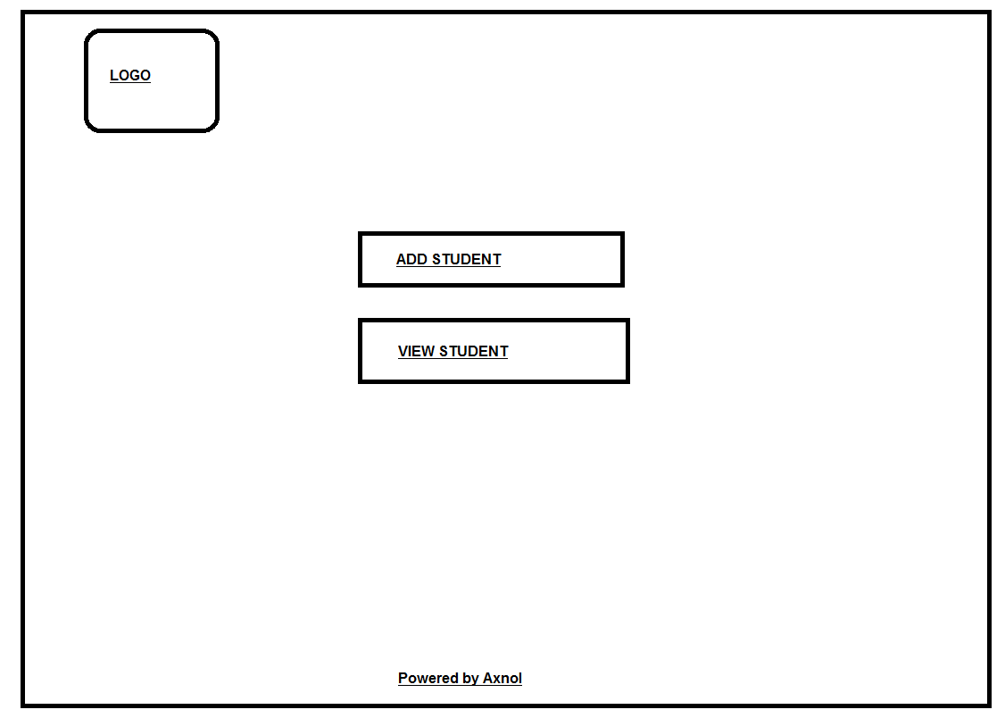

Registration Form

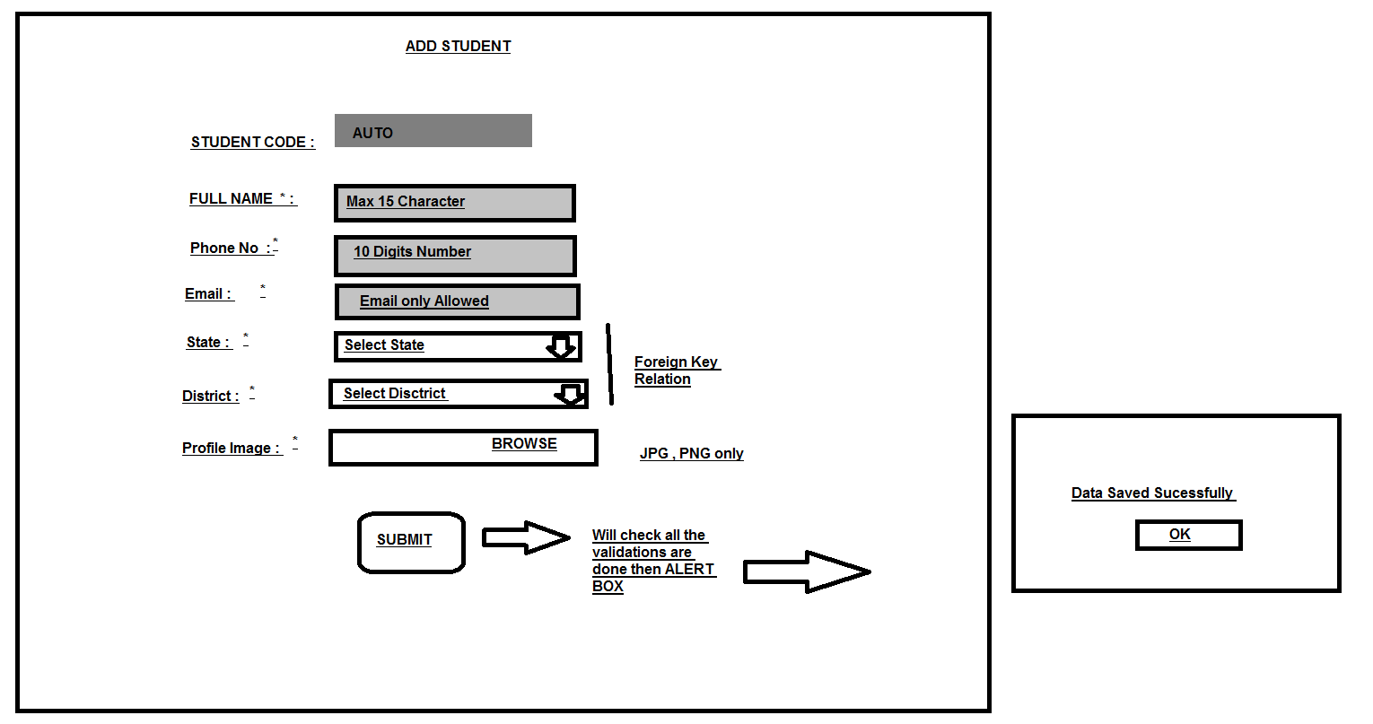

Student Listing

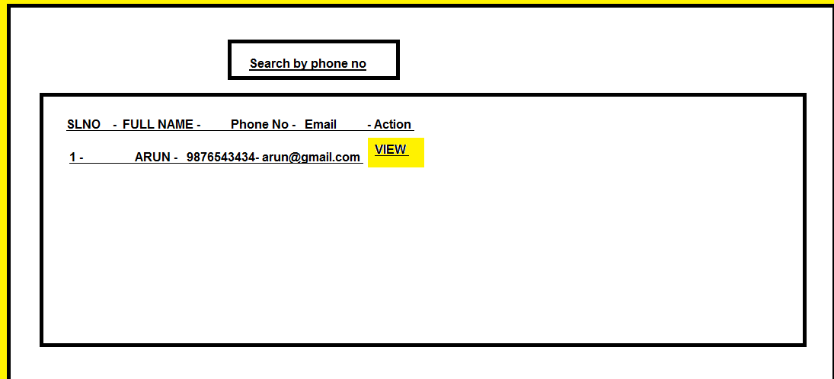

Profile View

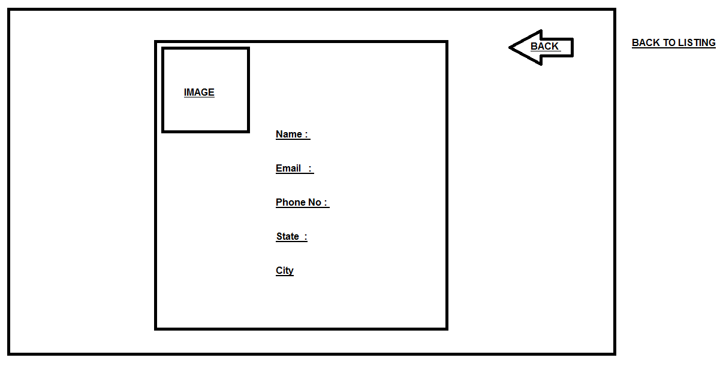

**Instructions**

Technology : Python with Postgresql or Django latest version

UI should be neat and clean . Can use Bootstrap templates .

**Result Expected**

**1. Share the Process Video of the Form results**

**2. Share the Code and DB with us for review**

**Duration : 3 Hours**